1. We will go for XML configuration which is very common in market.
2. 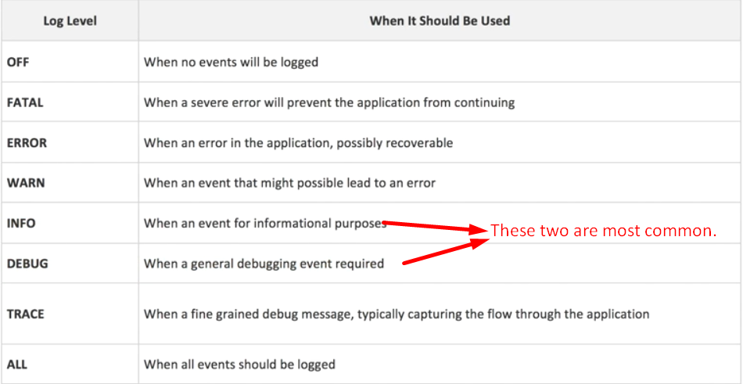
3. Where to save configuration file?

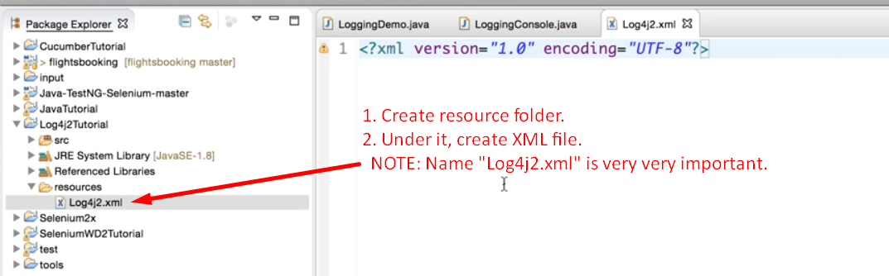

1. 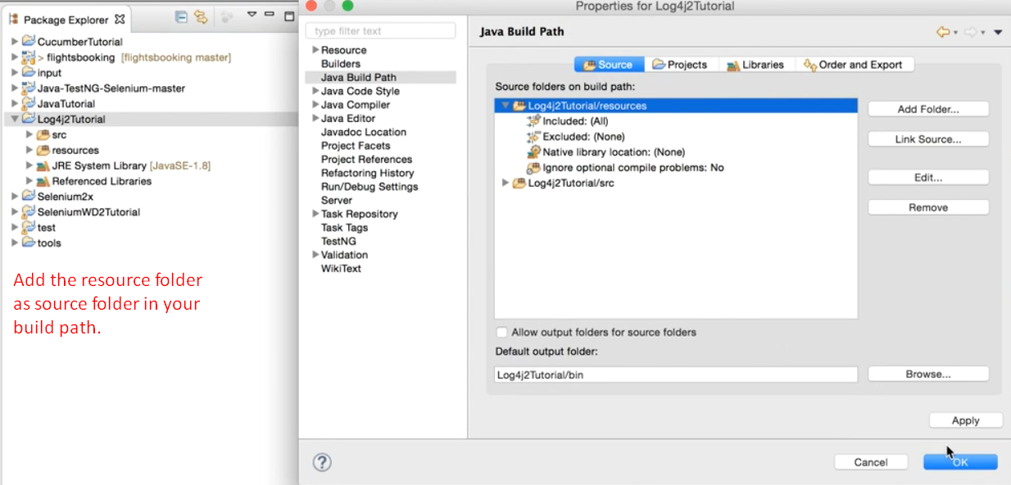
2. 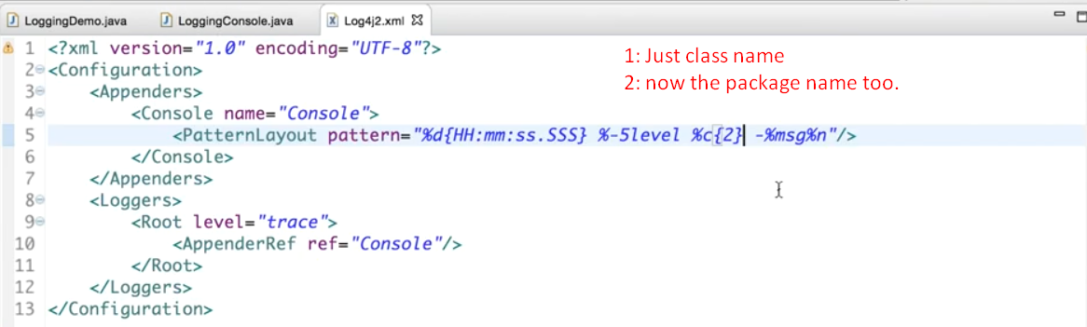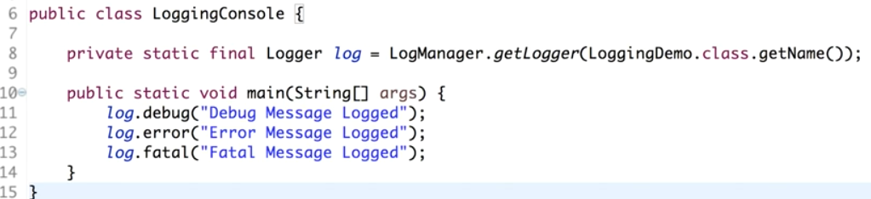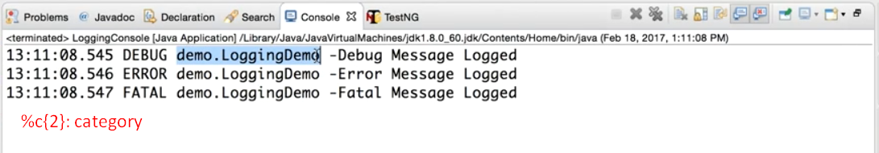  
   %c{packageLevel}